- Deliverables:
  - Python scripts for ingestion (e.g., using pandas, requests etc.)
  - A log file showing successful ingestion runs
  - Screenshots of ingested data stored in raw format
Kaggle api downloaded file
Screenshot of raw file - bank_churn_api_raw.csv
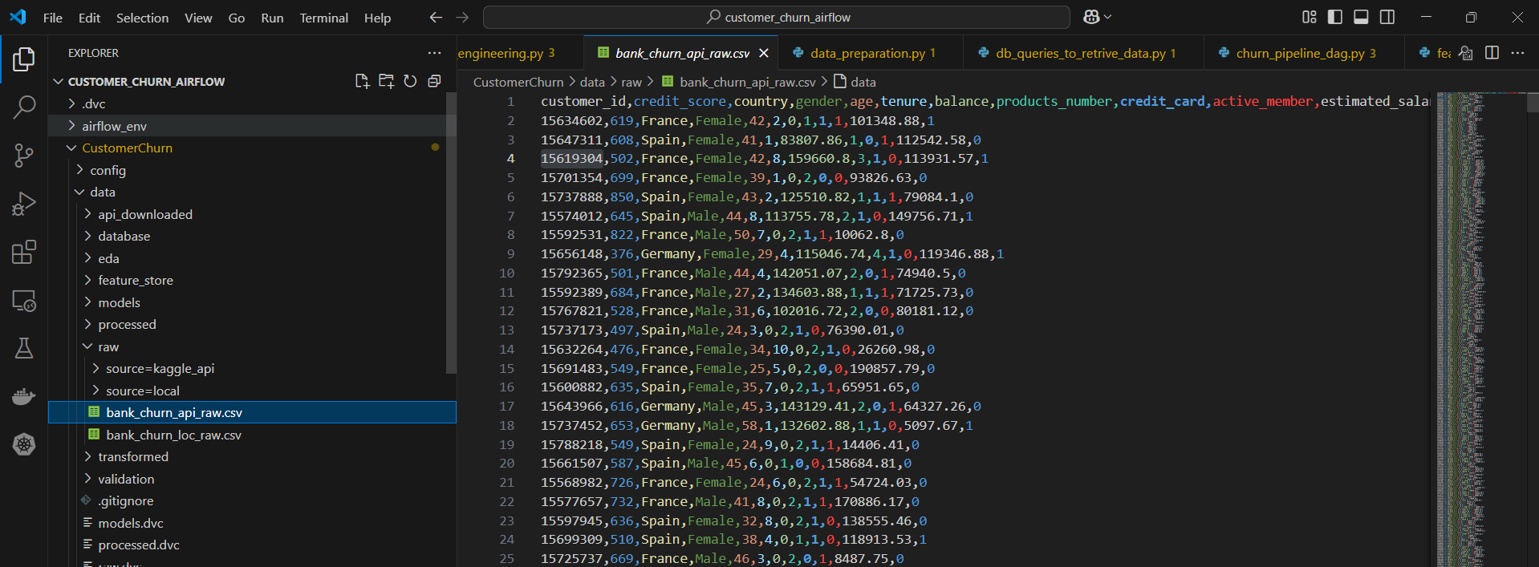

Screenshot of log file - Log for ingesting api file
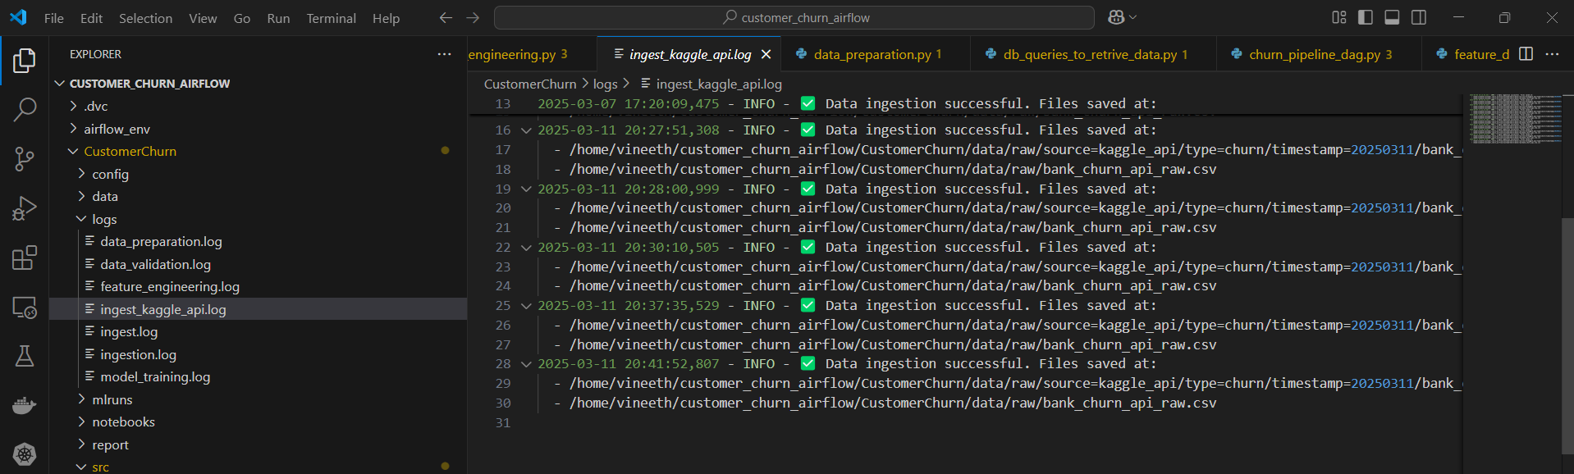

Local file
Screenshot of raw file - bank_churn_loc_raw.csv
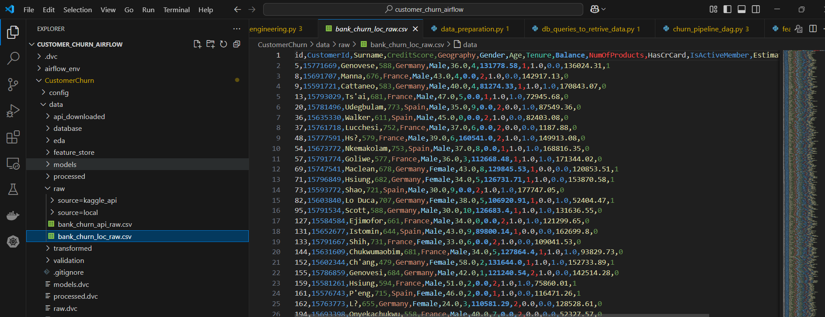

Screenshot of log file - Log for ingestion local file
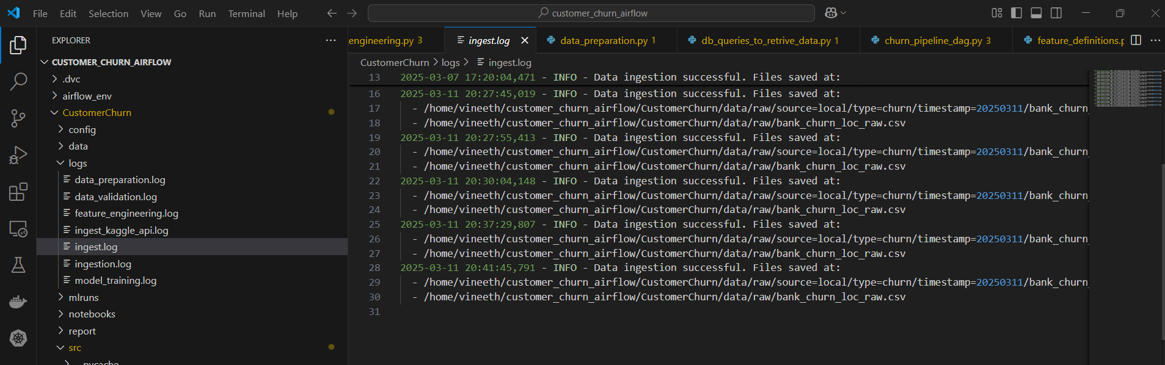

Log file showing the status of ingestion

